Enhancing Brain Tumor Diagnosis with MRI and Neural Networks

Introduction

Brain tumors are abnormal growths of cells within the brain or central spinal canal, which can be either benign (non-cancerous) or malignant (cancerous). Common types of brain tumors include gliomas, meningiomas, and pituitary tumors, each with unique characteristics that influence their behavior, growth rate, and response to treatment.

The timely and accurate detection of brain tumors is vital for effective treatment and improved patient outcomes. In this report, we explore the application of advanced deep learning techniques to enhance the diagnosis of brain tumors using MRI scans. By leveraging the power of neural networks, we aim to develop a reliable and efficient tool for the medical community, facilitating the early detection and precise localization of tumors.

Audience

**Doctors and Radiologists:** These medical professionals are at the forefront of patient care and diagnosis. The implementation of deep learning models in MRI analysis can significantly enhance their diagnostic accuracy and efficiency, allowing them to detect brain tumors at earlier stages and make more informed decisions about treatment plans.

**Hospitals and Medical Centers:** Healthcare institutions can integrate these advanced diagnostic tools into their existing systems to streamline workflow processes, optimize resource allocation, and improve overall patient care. The automation of MRI scan analysis can reduce the workload on radiologists and allow hospitals to serve a larger number of patients more efficiently.

**Insurance Companies:** Insurance providers can benefit from the reduced costs associated with early diagnosis and treatment of brain tumors. Early detection can prevent the progression of tumors to more advanced stages, which are often more expensive to treat. Additionally, improved diagnostic accuracy can lead to fewer misdiagnoses and unnecessary treatments, further optimizing healthcare costs.

**Medical Researchers and Academics:** Researchers can leverage the findings and methodologies presented in this report to further advance the field of medical imaging and diagnostic AI. The data and results can provide a foundation for future studies aimed at improving the accuracy and efficiency of tumor detection models.

Data

The dataset used for this project, taken from Kaggel.com, comprises MRI images of brain scans categorized into four classes: glioma, meningioma, no tumor, and pituitary tumors. Each category includes a diverse set of images captured from different angles and perspectives, providing a comprehensive representation of the various tumor types and their characteristics.

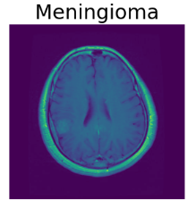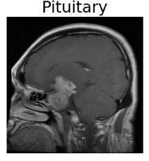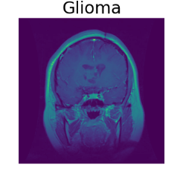

This diverse dataset ensures that the model is trained and tested on a variety of brain MRI images, enabling it to learn and generalize well across different tumor types and imaging conditions.

Data Preprocessing

To ensure the highest quality input for our model, several preprocessing steps were applied to the MRI images. First, we removed blurred images from the dataset to enhance the clarity and reliability of the data. This was done by calculating the variance of the Laplacian of each image, with images falling below a certain threshold being classified as blurred and subsequently excluded.

Additionally, we performed normalization by scaling the pixel values of all images to a range of 0 to 1. This step ensures that the model processes each image on the same scale, preventing any single pixel value from disproportionately affecting the training process.

Labels for the tumor types were encoded into numerical values, making them suitable for the classification task. We then split the dataset into training and testing sets, with 80% of the data used for training and 20% reserved for testing.

Exploratory Data Analysis (EDA)

In our exploratory data analysis, we confirmed that all MRI images were in RGB color format, ensuring consistency across the dataset. Each image was resized to a uniform dimension of 168x168 pixels, standardizing the input size for the neural network.

The distribution of mean pixel values (shown below) demonstrates a right-skewed shape, with most images having mean values between 20 and 60, resulting in an overall mean of 47.55. This suggests that the majority of images have relatively low average pixel intensities, which is characteristic of MRI scans' inherently dark backgrounds.

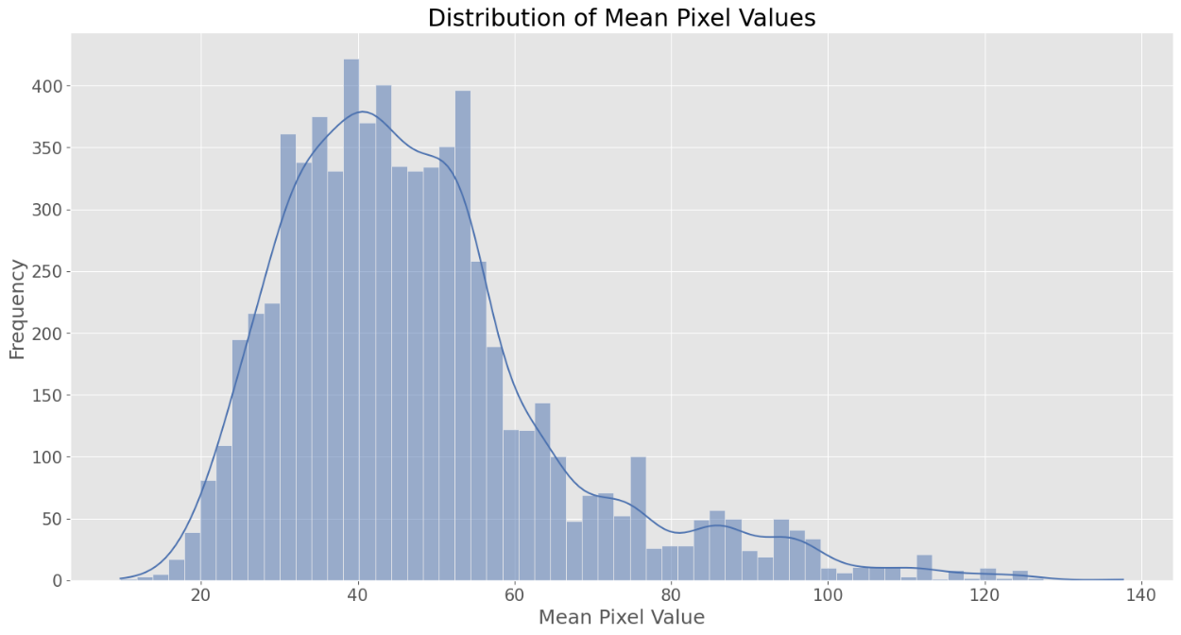

Similarly, the distribution of the standard deviation of pixel values (not shown) also exhibits a slight right-skew, with most images displaying standard deviations between 30 and 60. This indicates a moderate level of variation in pixel intensities within the images, reflective of the diverse tissue densities and structures captured in brain MRI scans.

These findings suggest that the images maintain a consistent intensity profile, which is advantageous for training deep learning models for tumor detection and classification.

Modeling

In this project, we developed a convolutional neural network (CNN) to detect and classify brain tumors from MRI images. CNNs are particularly well-suited for image recognition tasks due to their ability to automatically learn and extract relevant features from input images. During our experiments, we also explored other advanced models such as DenseNet and MobileNet. While these models showed promising results, they did not perform as well as the CNN. The CNN achieved a higher accuracy and better overall performance in correctly identifying and classifying the brain tumor types, demonstrating its robustness and suitability for this specific task.

**Model Architecture**: Our CNN model processes images of size 168x168 pixels in RGB format. It consists of three main sections, each designed to progressively extract more complex features. Each section includes convolutional layers to detect features, batch normalization layers to stabilize training, max pooling layers to reduce spatial dimensions, and dropout layers to prevent overfitting. Specifically, the first block has 32 filters, the second has 64 filters, and the third has 128 filters, all using a 3x3 filter size and ReLU activation function.

**Compilation and Optimization**: The model was compiled using the Adam optimizer with a learning rate of 0.001, which is known for its efficiency in training deep learning models. The loss function used was sparse categorical crossentropy, suitable for our multi-class classification task. The model's performance was evaluated using the accuracy metric.

**Training Process**: The training process involved running the model for up to 20 epochs with a batch size of 16. An early stopping callback was implemented to monitor the validation loss, with a patience of 3 epochs to restore the best weights and prevent overfitting. Additionally, a ReduceLROnPlateau callback was used to reduce the learning rate if the validation loss plateaued, ensuring better convergence.

**Evaluation and Results**: The model demonstrated strong performance, achieving a test accuracy of 94.45%. Training and validation accuracy/loss curves indicated effective learning with minimal overfitting.

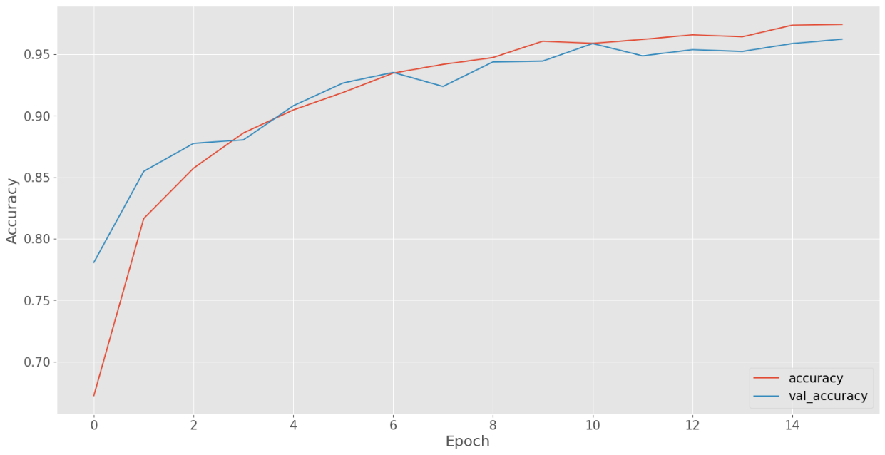

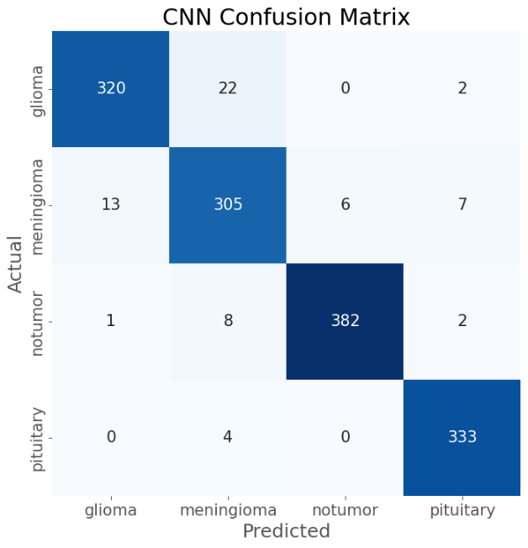

The confusion matrix further illustrated the model's performance across different tumor classes, highlighting high accuracy in identifying glioma, notumor, and pituitary tumor classes, with some misclassifications observed in the meningioma class. Overall, this model represents a robust tool for assisting medical professionals in early and accurate brain tumor diagnosis, ultimately enhancing patient care and treatment outcomes.

**Challenges and Solutions**: One of the main challenges was preventing overfitting, which was addressed through the use of dropout layers and early stopping. Additionally, data augmentation techniques were employed to enhance the model's ability to generalize to new, unseen images.

Recommendations

Based on the insights from our analysis and the strong performance of the CNN model, we recommend integrating this predictive model into clinical practice to enhance early detection and treatment of brain tumors. Healthcare providers, including doctors and radiologists, should deploy the model within electronic health record (EHR) systems to assist in accurately identifying and localizing tumors from MRI scans. The benefits extend to insurance companies, as early detection and treatment can reduce long-term healthcare costs, and to patients, who will benefit from more timely and accurate diagnoses.

Regular updates and refinements to the model are crucial. Hyperparameter tuning, exploring advanced architectures such as 3D CNNs, and implementing transfer learning should be ongoing processes to improve model accuracy and reliability. Collaborations with medical institutions to access larger, more diverse datasets will further enhance the model's robustness. Additionally, developing user-friendly interfaces and ensuring compatibility with existing medical imaging systems will ease the model's integration into clinical workflows. Visualization tools can help medical professionals understand and trust the model's predictions. By implementing these recommendations, the healthcare system can improve its capability to detect and treat brain tumors early, resulting in better patient outcomes and potentially increasing survival rates.

Future Work

Based on our findings and the performance of the CNN model, we recommend several steps for future work and practical implementation. Enhancing the quality and quantity of data is crucial. Acquiring more high-quality MRI images and ensuring a balanced representation of all tumor classes can significantly improve model training and performance. Collaborating with medical institutions to access larger and more diverse datasets will be beneficial.

Model refinement should be an ongoing process. This includes hyperparameter tuning, exploring advanced architectures such as 3D CNNs and ensemble methods, and implementing transfer learning to leverage pre-existing models for improved accuracy. Additionally, integrating the model into clinical workflows is essential. Developing user-friendly interfaces and ensuring compatibility with existing medical imaging systems will facilitate seamless integration. Visualization tools can help medical professionals understand and trust the model's predictions.

Regular evaluation of the model with new data and in real-world clinical settings is necessary to ensure its robustness and reliability. Feedback from healthcare professionals can guide further improvements. Furthermore, integrating the model with additional clinical data, such as patient demographics and medical history, can provide a more comprehensive diagnostic tool, enhancing predictive accuracy and treatment planning. By following these recommendations, we can enhance the model's effectiveness in real-world applications, ultimately contributing to better patient outcomes through early and accurate brain tumor detection.

Conclusion

We successfully developed a convolutional neural network (CNN) to detect and classify different types of brain tumors from MRI images. The preprocessing phase involved normalizing image pixel values to ensure consistency and encoding tumor labels into numerical values. We split the data into training and testing sets to evaluate the model's performance on unseen data and applied data augmentation techniques to create a more diverse dataset, enhancing the model's ability to generalize well to new images.

Our CNN model was trained over multiple epochs, learning to identify patterns associated with four categories: glioma, meningioma, pituitary tumors, and non-tumor images. The training process was monitored using an early stopping mechanism to prevent overfitting. The model achieved a high test accuracy of 94.95%, demonstrating its effectiveness in correctly identifying the presence and type of brain tumor.

The confusion matrix provided a detailed breakdown of the model's performance across different tumor types. The model performed exceptionally well in identifying gliomas, non-tumor images, and pituitary tumors, with high accuracy rates. Although there were some misclassifications within the meningioma category, the overall results indicate a strong predictive capability. This model holds significant potential for aiding medical professionals in the early and accurate diagnosis of brain tumors, ultimately contributing to better patient outcomes through timely and targeted treatment interventions.